Homework: HTML5 Overview

Hello HTML
Create a HTML document holding the text "Hello HTML". Ensure you have <doctype>, <html>, <head>, <title> and <body>. Play with the other tags.

Paragraphs and Images of Text
Create an HTML page holding a few headings, each with a few paragraphs of text. Insert a few images. Play with the old formatting tags <b>, <i>, <u>, <strong>, <em>, <sup>, <sub>, <pre>, <br /> etc. Ensure you have <doctype>, <html>, <head>, <title> and <body>.

Runners Home
Write an HTML page like the image below (use headings, <div>, paragraphs and <ul>):
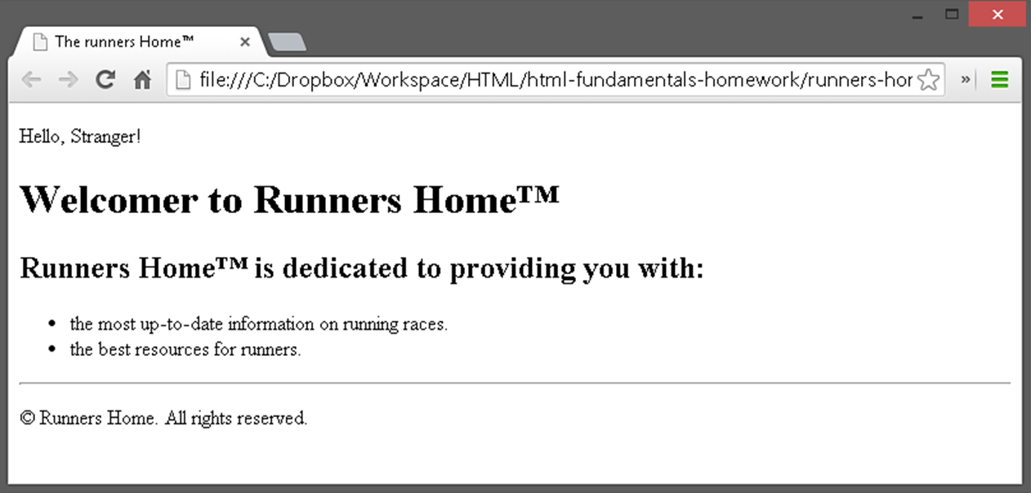

HTML Lists
Create a HTML page that holds nested lists like the example on the below (without the border and the rounded corners). Use <ol>, <ul> and <li>.
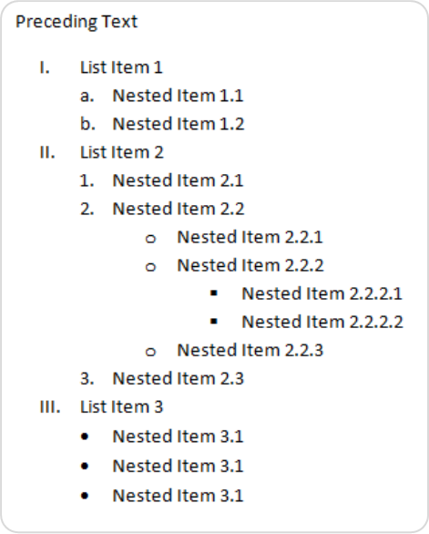

User Profile Pages
Create user profile Web pages named profile.html, friends page named friends.html and info page named home.html. Link them to one another using <a href="…"> tag. The pages should look like the following:
