Homework: HTML5 Tables

Simple Table
Create an HTML page like the image below (100% accuracy is not required).

Hint: Use table for the layout. Link the Chochev logo with https://chochev.eu.
Note: Using tables for creating website layout is deprecated; we use this approach only to practice the making of tables.

Exam Results
Create an HTML table like the image below (100% accuracy is not required). Use semantic table tags: <thead>, <tfoot>, <tbody>, etc.
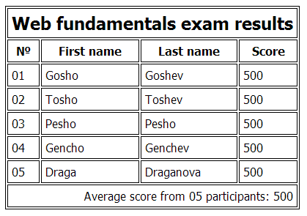

Nested Tables
Create an HTML table like the image below by using nested table (100% accuracy is not required). Link the SoftUni logo with https://chochev.eu. Make the link open in new tab.

Hint: Use tables and buttons.

***Calculator
Create a simple fully functional calculator, similar to the image below. You can use styles by your liking.
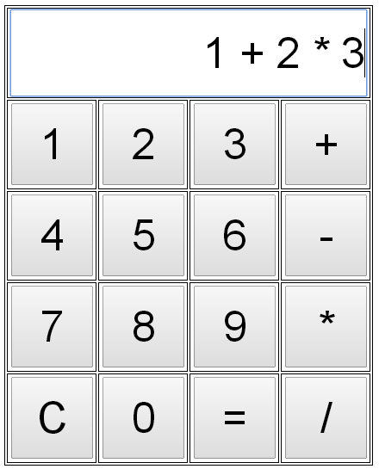
Hint: Use JavaScript to achieve the functionality of the calculator. You may calculate the entered expression by the eval(expression) function in JavaScript.

